Title V Modification Applications

Frequently Asked Questions (FAQs)

1) How do I start an application for a Title V operating permit modification in Iowa EASY Air?

Once your Iowa EASY Air user account is set up, the process to create an application for a Title V operating permit modification is the same as for an initial permit or renewal. Log in to Iowa EASY Air, then select “Apply New Submittal” in the top left corner of the screen.

This image is a screenshot of what the "Apply New Submittal" button looks like in the Iowa EASY Air program.
 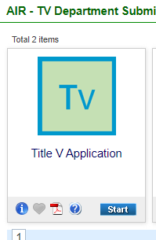

Then find the Title V Application icon and select “Start”.

On Form 1.0, select the button for “Modification” and then use the drop-down box to select which type of modification you are submitting – Administrative Amendment, Minor Permit Modification, or Significant Modification. Then in the “Application Description” box, explain how the permit should be modified.

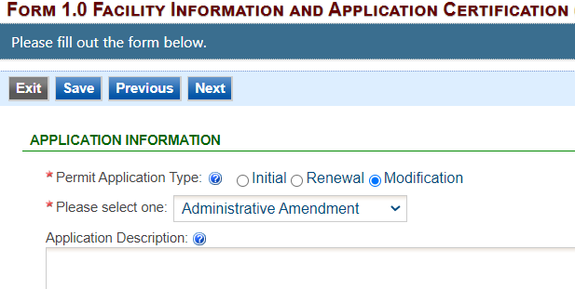

2) How do I determine the modification type?

* An administrative amendment includes changes such as correcting typographical errors, updating facility contact/ownership information, updating the insignificant activities list, etc.
* A significant modification may include significant changes to monitoring permit terms, relaxation of reporting or recordkeeping permit requirements, or changes in compliance methods.
* Minor modifications include revisions that do not violate any applicable requirements, do not relax any requirements, do not involve significant changes to existing monitoring, reporting, or requirements, etc.

Please refer to the [Title V Operating Permit Modification Quick Reference Sheet](https://www.iowadnr.gov/portals/idnr/uploads/air/operpermit/tv_oper_permit_mod_quick_ref.pdf) for more details, examples, and submission requirements.

3) Is the Application Description required?

No, a description is not required, but it is extremely helpful if you enter a detailed description of what parts of your permit you would like modified. It can be difficult to determine the correct modification type, and the description will help the permit writer evaluate your request.

4) Is every form required to be filled out?

No, only the forms that pertain to the information you want to modify are required. However, you must open every form and review it to pass validation. Click “Next” to move through the application and open subsequent forms. Remember to click “Save” on any page on which you add or edit information.

5) Are there any required attachments?

Attachments are not required for modification applications. However, if you are modifying potential emissions information or applicable requirements, you must attach the CAM Calculation worksheet or the Emission Point Applicable Requirements document.

6) What if I need to change the Title V Responsible Official?

The first step is to set up an Iowa EASY Air user account for the new Title V Responsible Official, replacing the previous one. [Account Registration Instructions for Responsible Officials](https://www.iowadnr.gov/portals/idnr/uploads/air/eAirServices/Iowa%20DNR%20EASY%20Air%20Account%20Registration%20Instructions_RO.pdf) and [Instructions for Managing Associated Consultants and Preparers](https://www.iowadnr.gov/portals/idnr/uploads/air/eAirServices/Iowa%20EASY%20Air%20RO%20Manage%20Consultants%20&%20Preparers.pdf) are posted on the [eAirServices](https://www.iowadnr.gov/Environmental-Protection/Air-Quality/eAirServices) webpage. Once the Responsible Official’s account has been created, a Title V Application – Modification – Administrative Amendment should be created and submitted. See Question #1 for how to start the application. In this case, the only form that needs to be filled out within the application is Form 1.0 Facility Information and Application Certification. After saving the information on the Form 1.0, click ‘Next’ to move through subsequent forms and view them, and then validate them and submit the application for a modification.

7) When does the requirement to apply for air permits and report emissions electronically start?

The requirement to submit Title V operating permit applications and emissions inventory reports electronically begins on Jan. 1, 2023. You do not have to wait to make electronic submittals. You can take advantage of the benefits of submitting electronically now.

Electronic submittal makes permit application submittal and emissions reporting easier and more efficient, and allows businesses to submit their information from any location at any time. This speeds up the DNR’s ability to issue permits and increases data accuracy.

8) Can I still use the EZ Modification Form?

No, starting January 1, 2023, the paper EZ Modification Form will no longer be available and applications for Title V modifications must be submitted electronically in Iowa EASY Air.

9) What alternatives does DNR offer if I can’t submit electronically?

If a facility is unable to submit electronically, the facility may use the standard variance request process found in 567 Iowa Administrative Code Chapter 21 to request an extension or a one-time paper submittal. DNR approves variances on a case-by-case basis.

10) What resources are available to help me submit electronically?

Online: Start at the DNR’s [eAirServices](https://www.iowadnr.gov/Environmental-Protection/Air-Quality/eAirServices) webpage. Find resources, including FAQs, guidance documents, user guides, and training videos. Both applications contain built-in prompts and tooltips to help users input data.

Help: During business hours, contact the Help Desk at easyair@dnr.iowa.gov or call 515-725-9569. For specific questions about Title V operating permit applications, contact a Title V senior environmental specialist at 515-725-9511 or 515-725-9537.

Training: The DNR will announce live training sessions through the “Air Quality Technical Updates” newsletter. Sign up at [www.IowaCleanAir.gov](http://www.IowaCleanAir.gov). Videos of previous training are posted on the[eAirServices](https://www.iowadnr.gov/Environmental-Protection/Air-Quality/eAirServices)webpage under the “Training” heading.

All resources, training, and Help Desk services are free.

This FAQ has been prepared by the Iowa Department of Natural Resources (DNR) to provide facilities with implementation information associated with the state’s electronic permit application and emissions inventory systems. This document is intended solely as guidance, cannot be used to bind the DNR and is not a substitute for reading applicable statutes and rules.